Topic 3 Exercise
KM Clustering
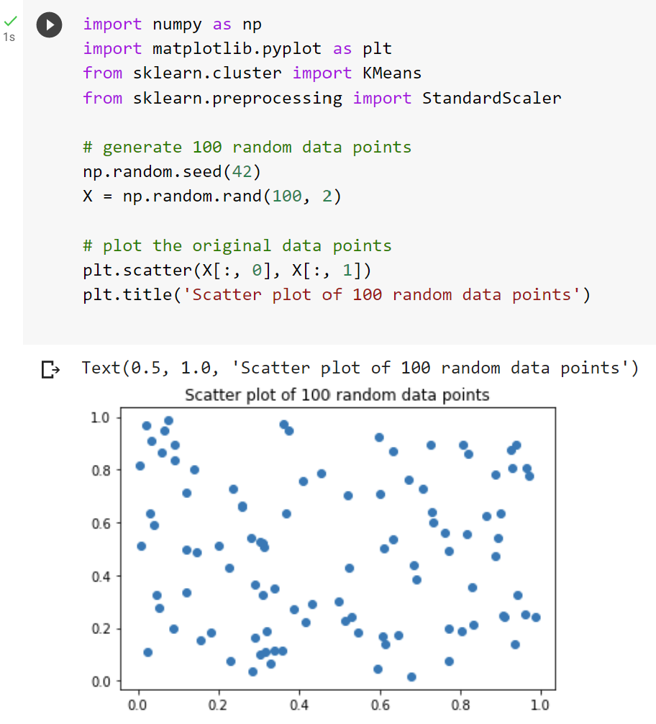
Image from Google Colab by Arden University.

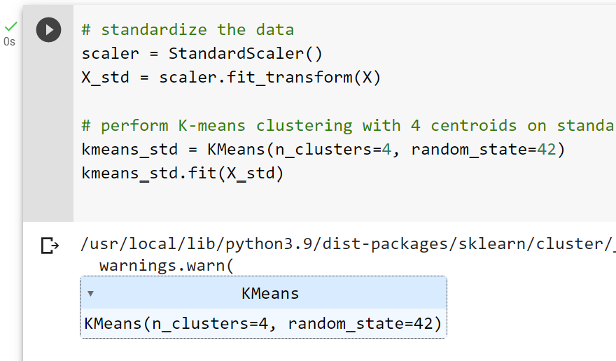
Image from Google Colab by Arden University.

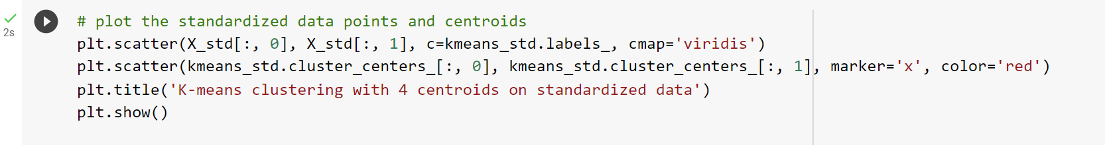
Image from Google Colab by Arden University.

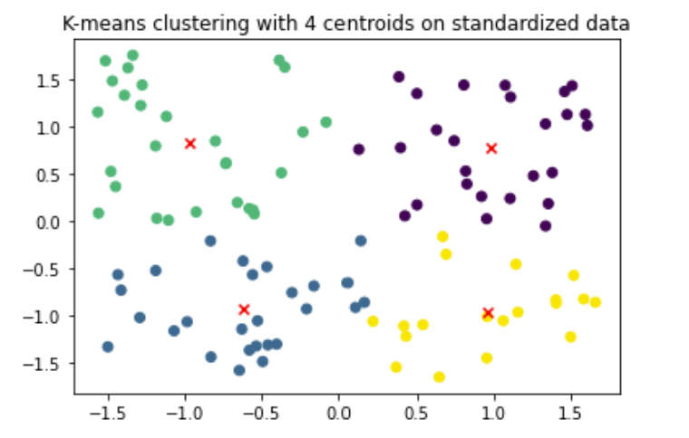
Image from Google Colab by Arden University.

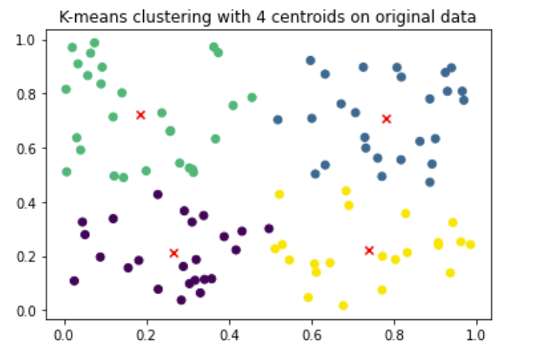
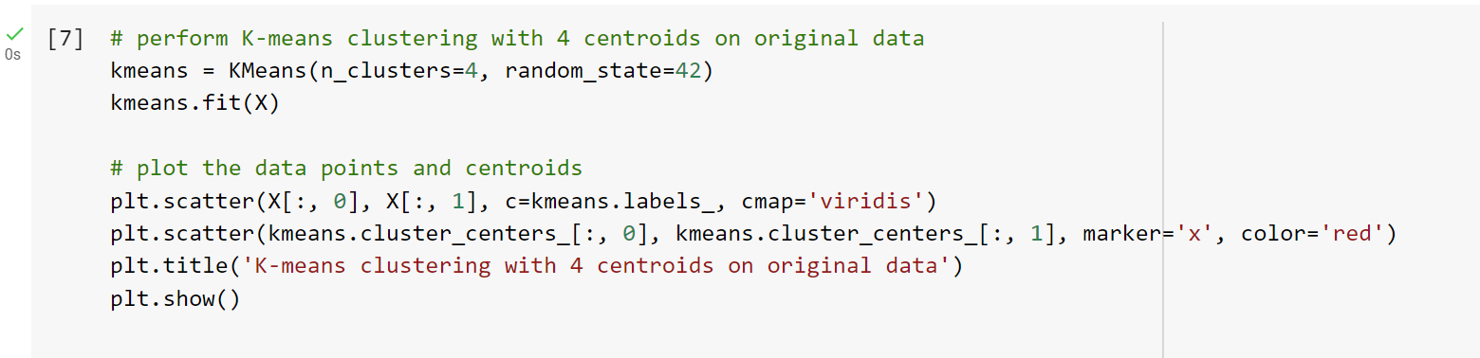
Images from Google Colab by Arden University.

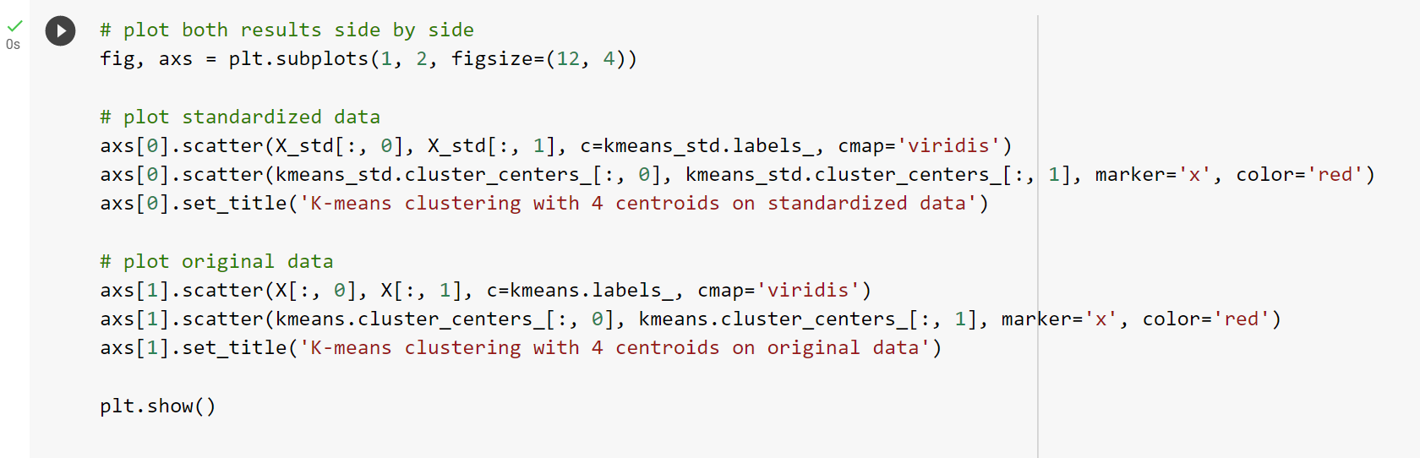
Image from Google Colab by Arden University.
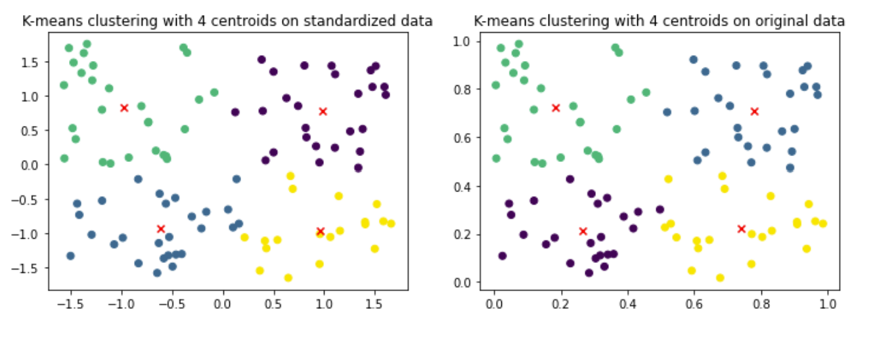
Image from Google Colab by Arden University.

